|  |
| --- |
| RAWKHIGH |
| Text Adventure Breakdown |
| **Text Adventure** |
| Version #1.0  All work Copyright © 2012 by RAWKHIGH.  All rights reserved. |
| **Stephen McArthur** |
|  |

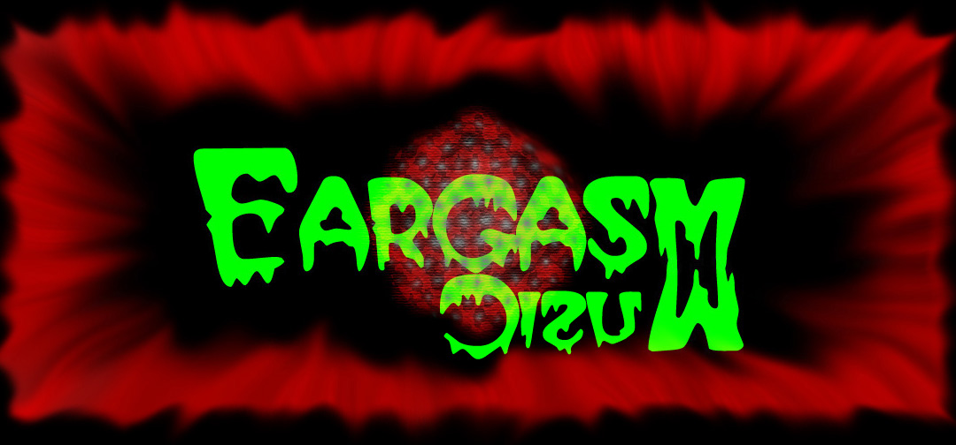

**Insert a Company Logo here**

|  |
| --- |
| May 16th 2012 |

**Table of Contents**

[Your Table of Contents should go here. Make sure that your document’s sections are hyperlinked to their corresponding pages.]

**Version History**

V0.1 – Broke down supplied code to parts able to be reused for new game.

V0.2 – All old code is now removed beginning of game taking shape

V0.3 – Relative path of events take shape

V0.4 – Almost finished the pathways

V.05 – Added random endings to pathways, added back tracking and game closely done

1. **Game Overview**

*Your father was killed by one of the kings’ guard and you find yourself on an adventure to find your fathers killer.*

1. **Game Play Mechanics**

*Text based game, where you go East, West or South to find your way to the end.*

1. **Camera**

*Text based.*

1. **Controls**

*Keyboard W, E or S*

1. **Saving and Loading**

*No Saving*

1. **Interface Sketch**

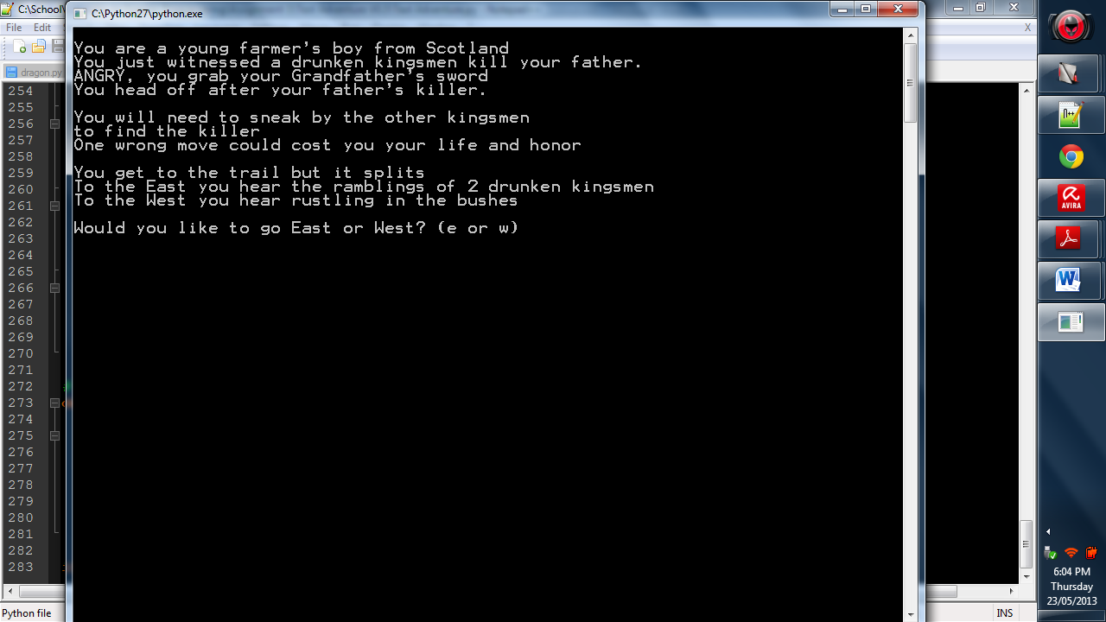

1. **Menu and Screen Descriptions**

*No Menu*

1. **Game World**

*(Describe Your Game Environment)*

1. **Levels**

*(Describe Each of your game levels)*

1. **Game Progression**
2. **Characters**

*(Describe Your game avatar if applicable)*

1. **Non-player Characters**

(Describe Any Computer controlled Allies and how they work)

1. **Enemies**

*(Describe computer-generated enemies and boss monsters)*

1. **Weapons**

*(Describe any weapons available to the user)*

1. **Items**

*(Describe any in-game items that can help or hinder the user)*

1. **Abilities**
2. **Vehicles**
3. **Script**
4. **Scoring**
5. **Puzzles/Mini-games**
6. **Bonuses**
7. **Cheat Codes**
8. **Sound Index**

*(Include an index of all your sound clips)*

1. **Story Index**

*(Outline your game story here)*

1. **Art / Multimedia Index**

*(Include an index of all your graphic and video assets here)*

1. **Design Notes**

*(Include additional design notes here)*

1. **Future Features**

*(Include any future features that are planned to be implemented)*